What is a Regular Expression(RegEx)?

A regular expression is a sequence of characters that forms a search pattern. When you search for data in a text, you can use this search pattern to describe what you are searching for.

A regular expression can be a single character, or a more complicated pattern.

Regular expressions can be used to perform all types of **text search** and **text replace** operations.

Java does not have a built-in Regular Expression class, but we can import the java.util.regex package to work with regular expressions. The package includes the following classes:

* Pattern Class - Defines a pattern (to be used in a search)
* Matcher Class - Used to search for the pattern
* PatternSyntaxException Class - Indicates syntax error in a regular expression pattern

🡺Example :

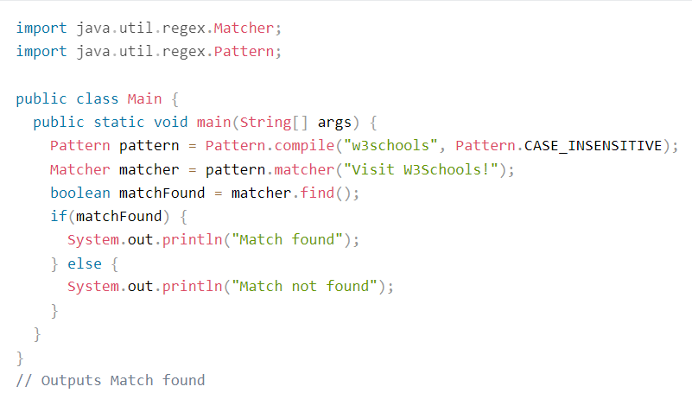

🡺Exanple Exaplained :

In this example, The word "w3schools" is being searched for in a sentence.

First, the pattern is created using the Pattern.compile() method. The first parameter indicates which pattern is being searched for and the second parameter has a flag to indicates that the search should be case-insensitive. The second parameter is optional.

The matcher() method is used to search for the pattern in a string. It returns a Matcher object which contains information about the search that was performed.

The find() method returns true if the pattern was found in the string and false if it was not found.